**Note:**

1. I did not include vendor in the source code
2. Note the passwords for users hi in the pictures
   1. Are abc123 for users hello and hi
      1. hi changes theirs to 1234567
      2. hello changes theirs to 12345678

1 php artisan serve:

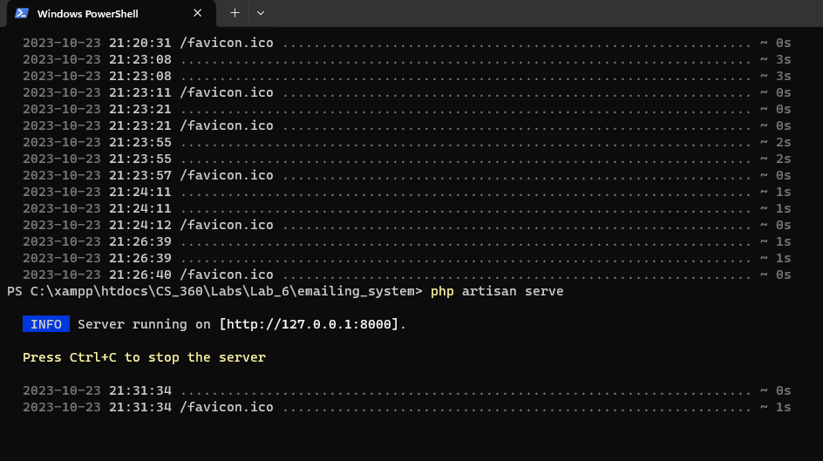

2 Users table before any users are registered:

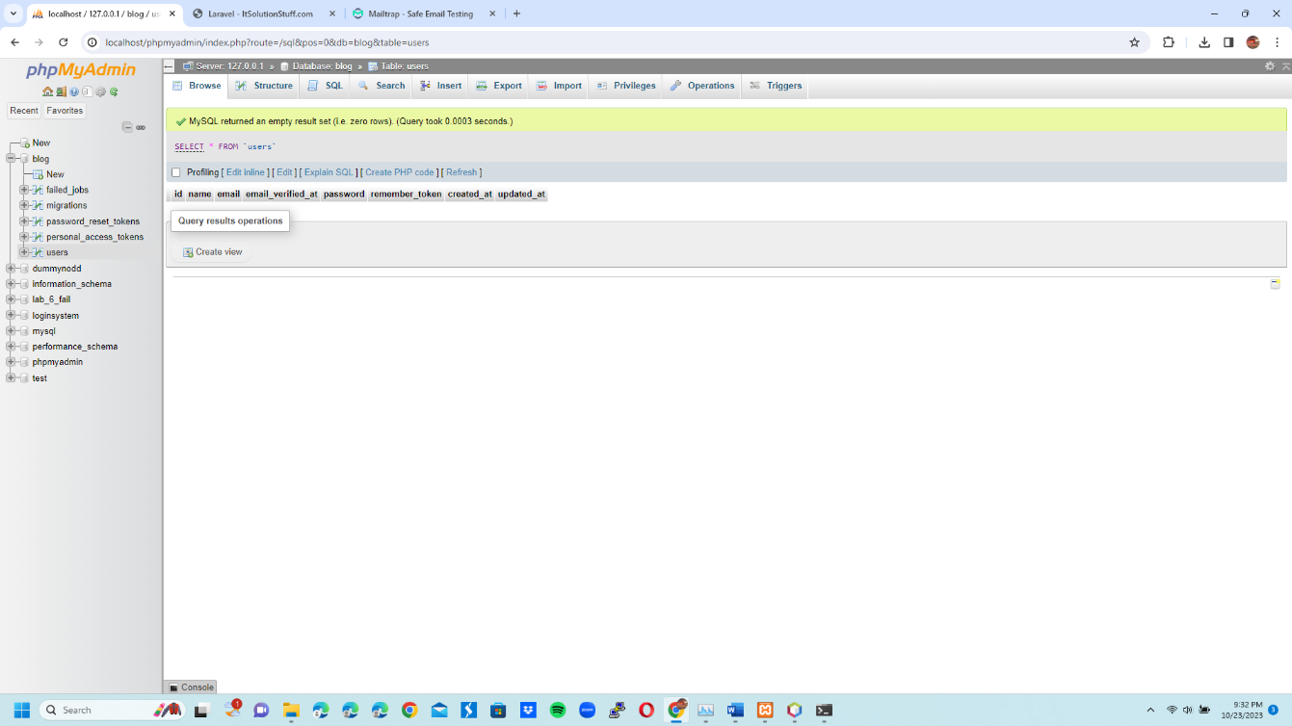

3 Register user hello:

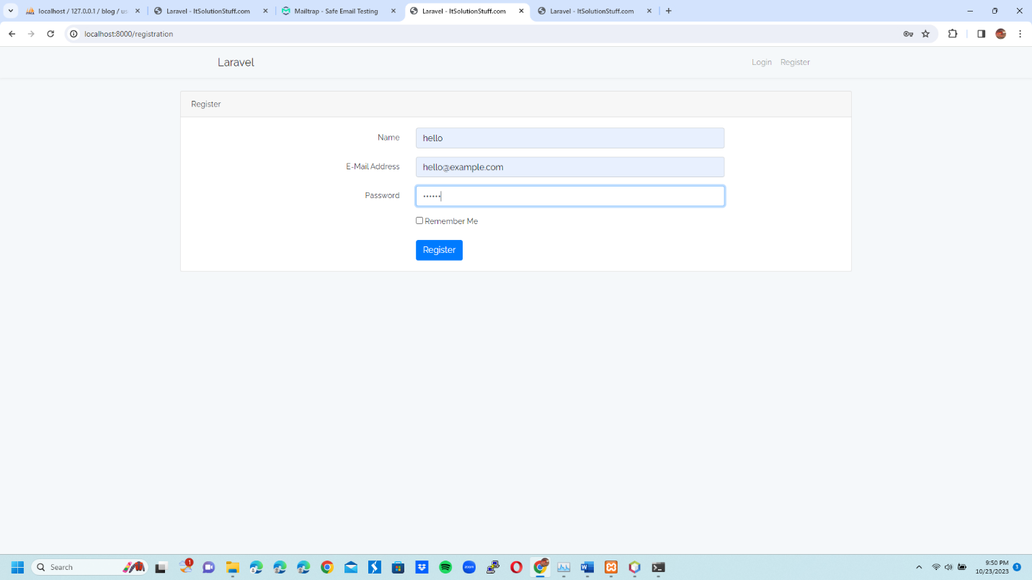

4 Log in with user hello:

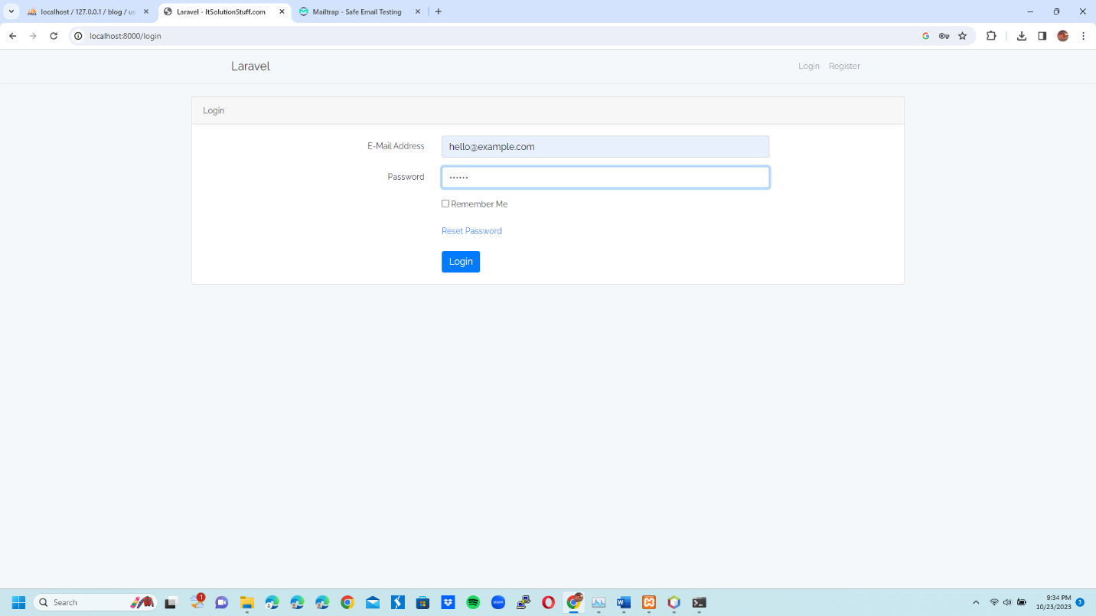

5 Successfully log in with user hello:

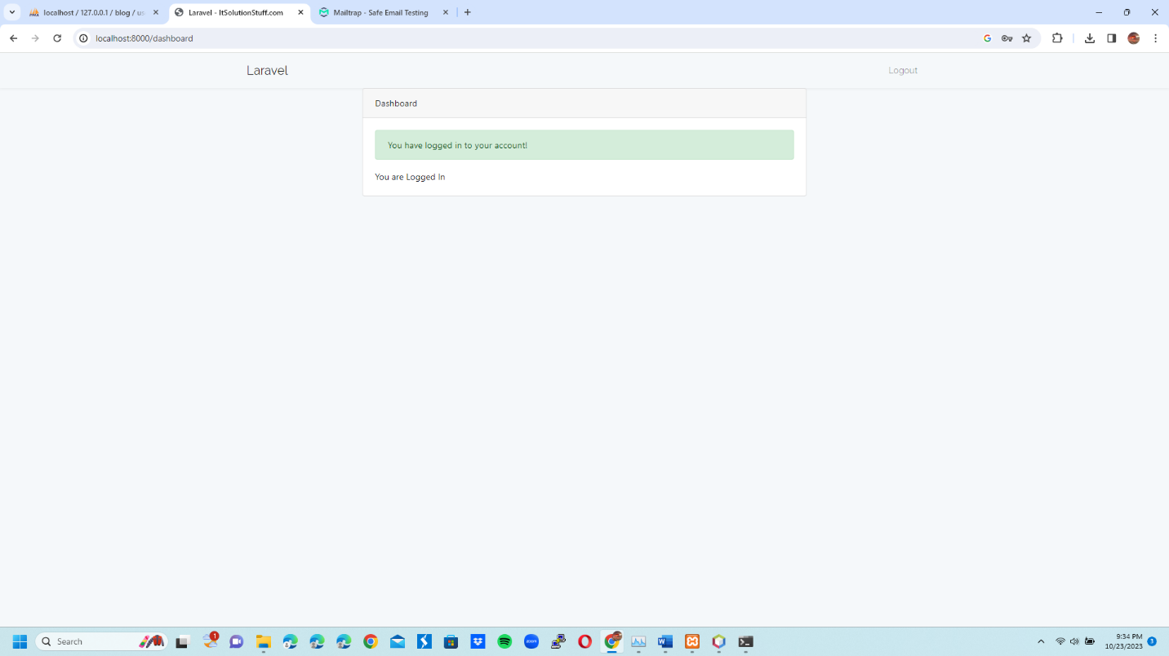

6 Register user hi:

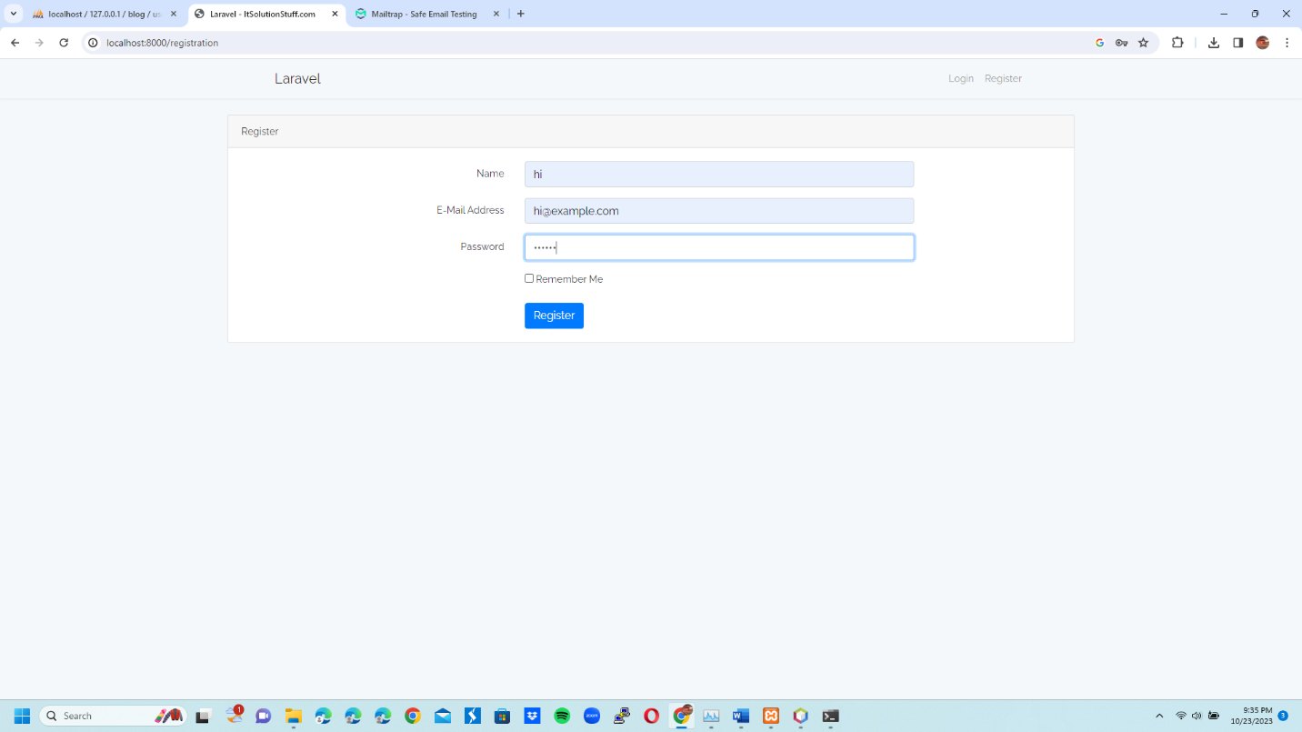

7 Log in with user hi:

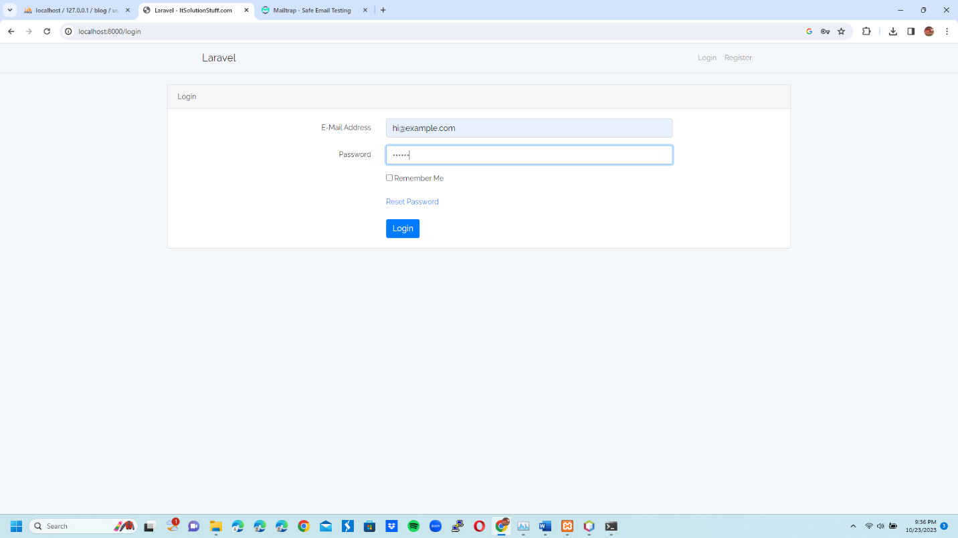

8 Successfully log in with user hi:



9 Try registering hi as a user twice with the same email:



10 Failure message for trying to register same user with same email:

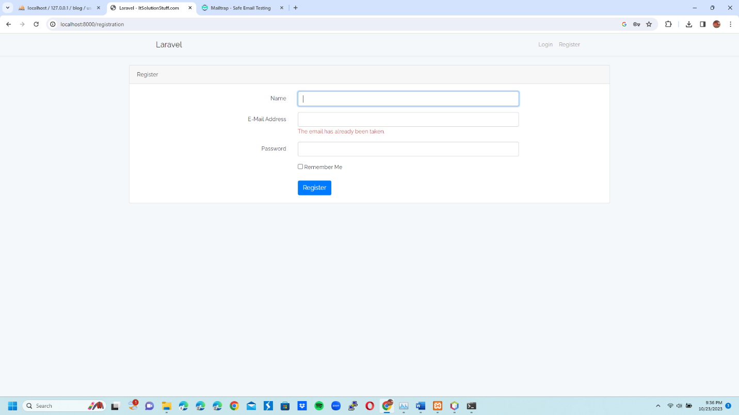

11 Users table in the database:

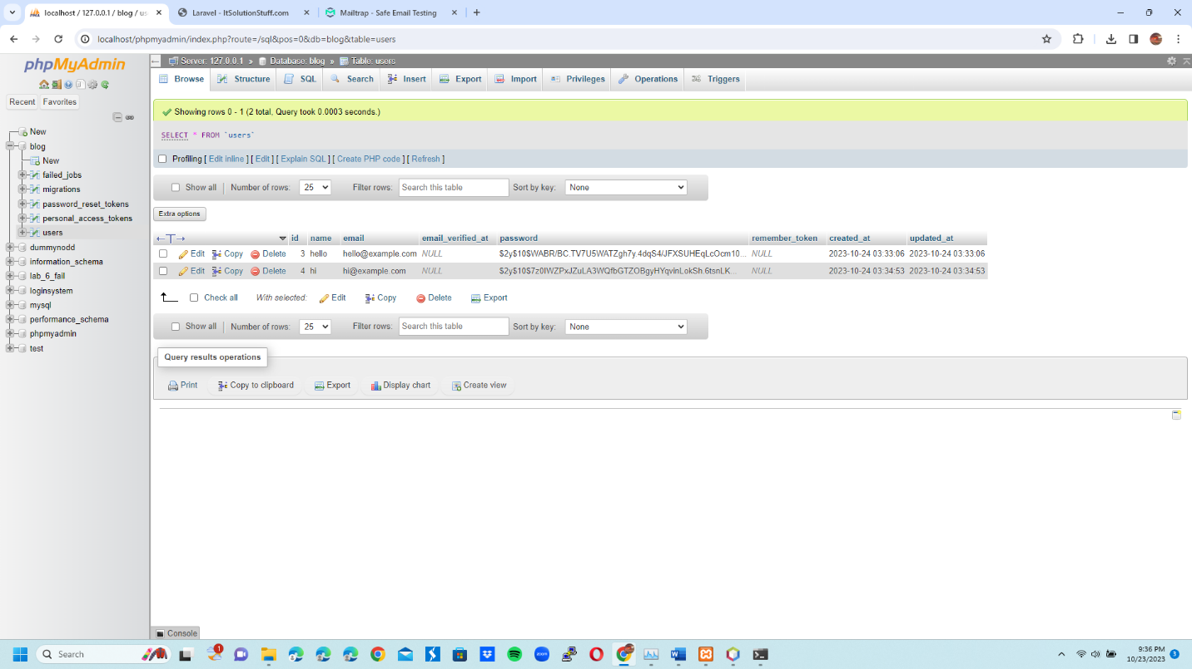

12 Reset password of hi:

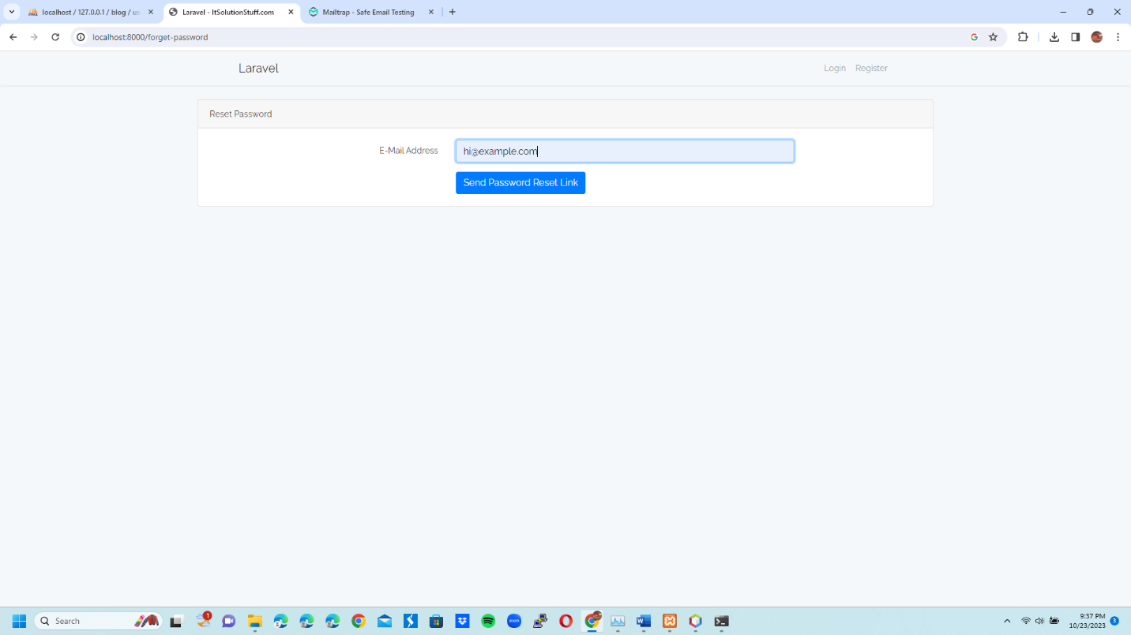

13 Reset password email sent to hi:

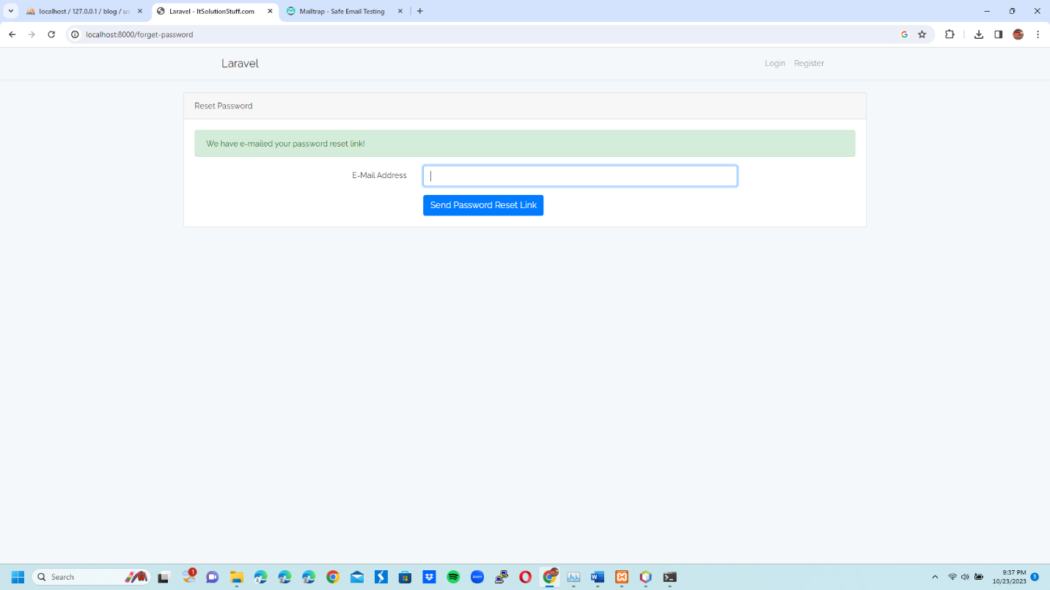

14 Reset password email for user hi viewed in mailtrap:

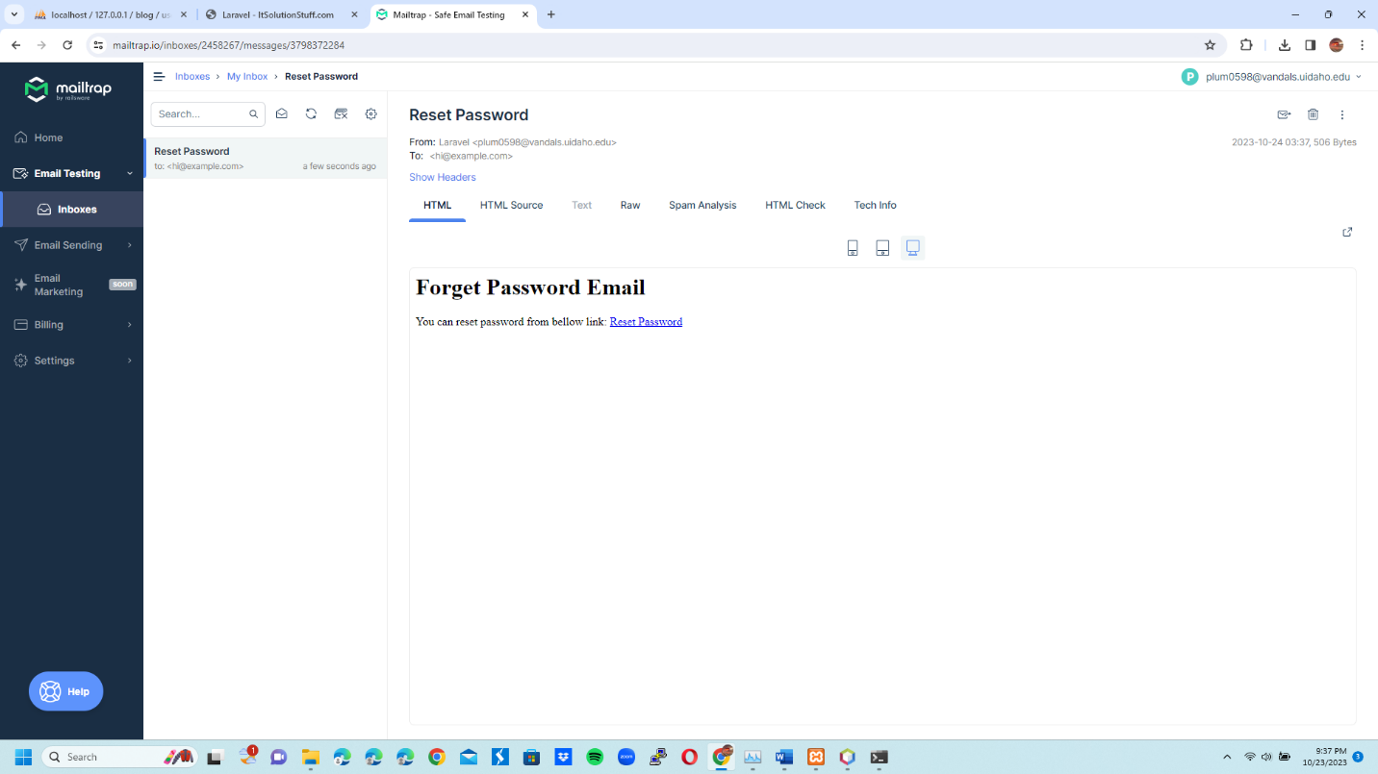

15 Fill hi user info in reset password link:

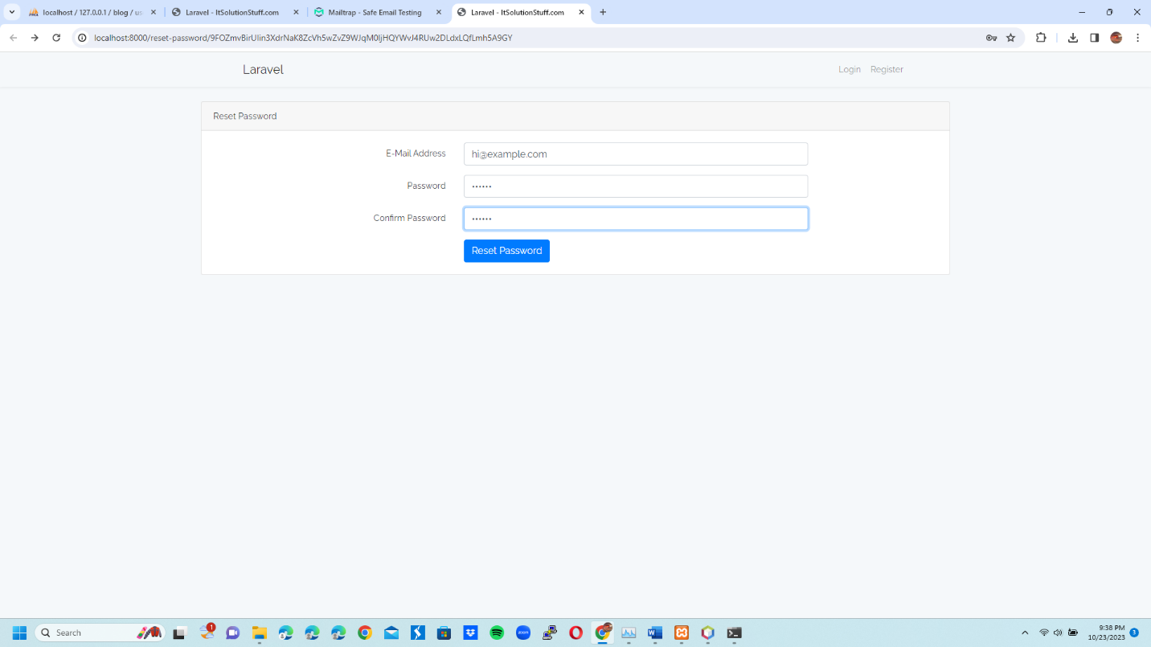

16 Log in with hi’s new password which is 7 characters long compared to 6 previously:

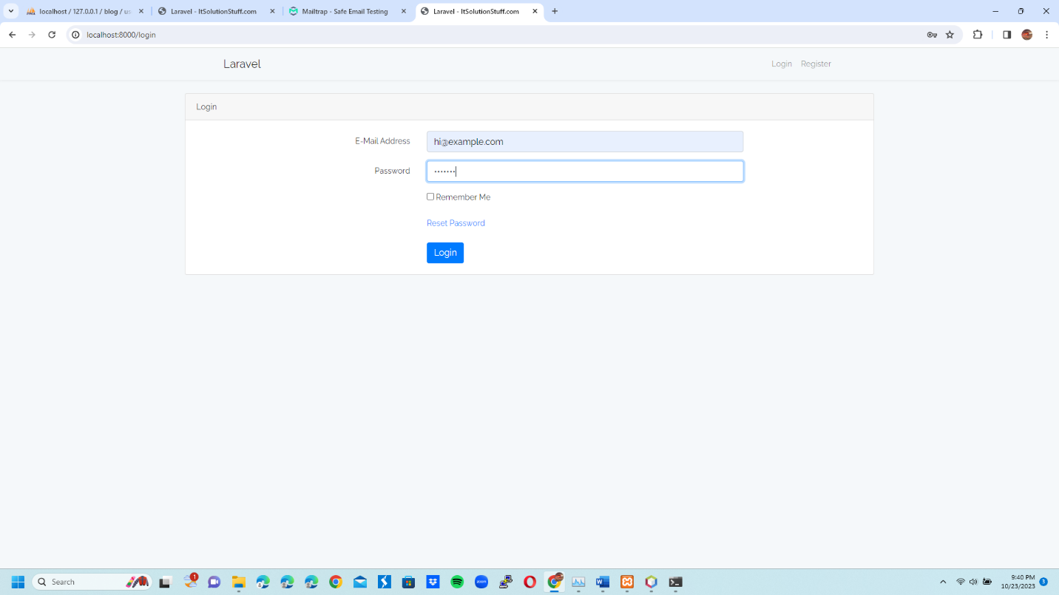

17 Succesfully log in with hi’s new password: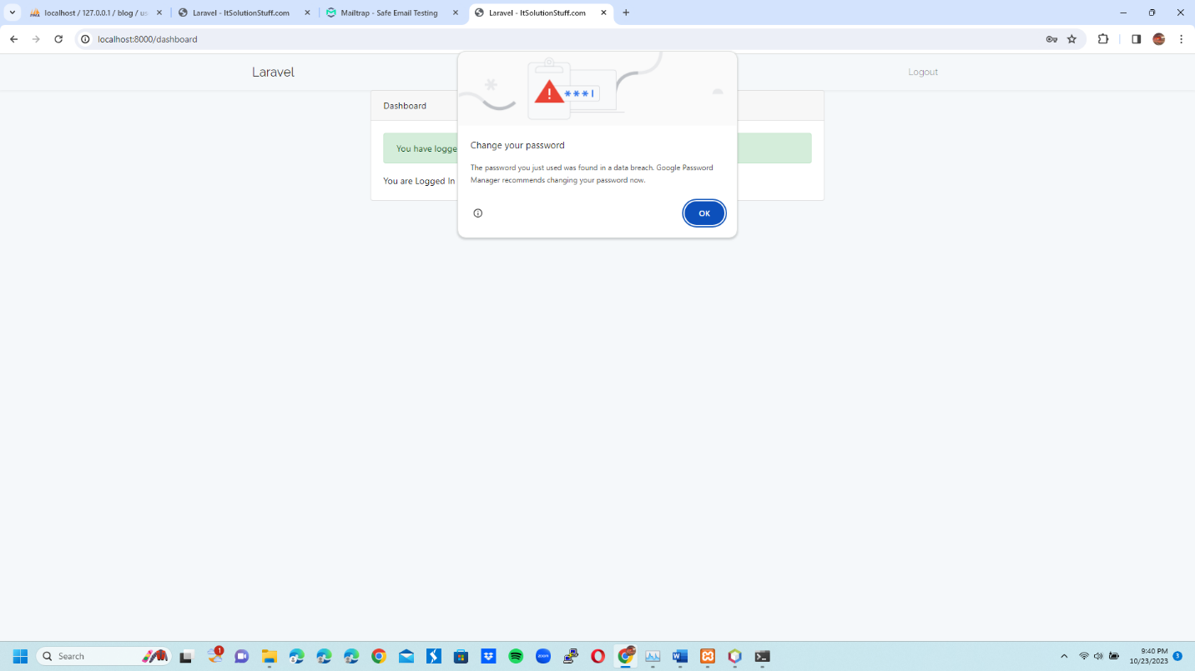18 Reset password of user hello:

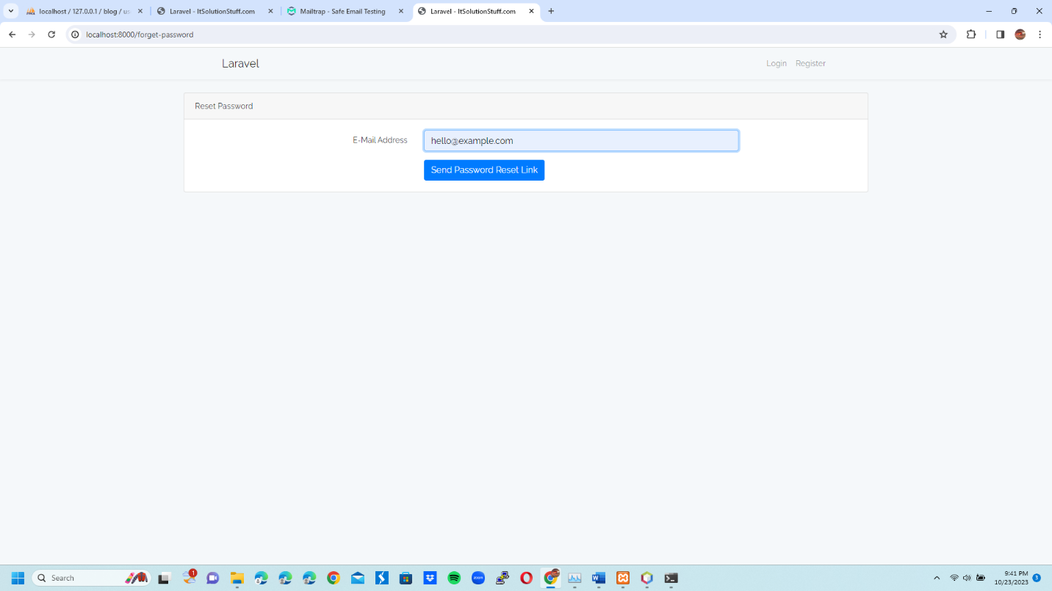

19 Reset password email for user hello viewed in mailtrap:

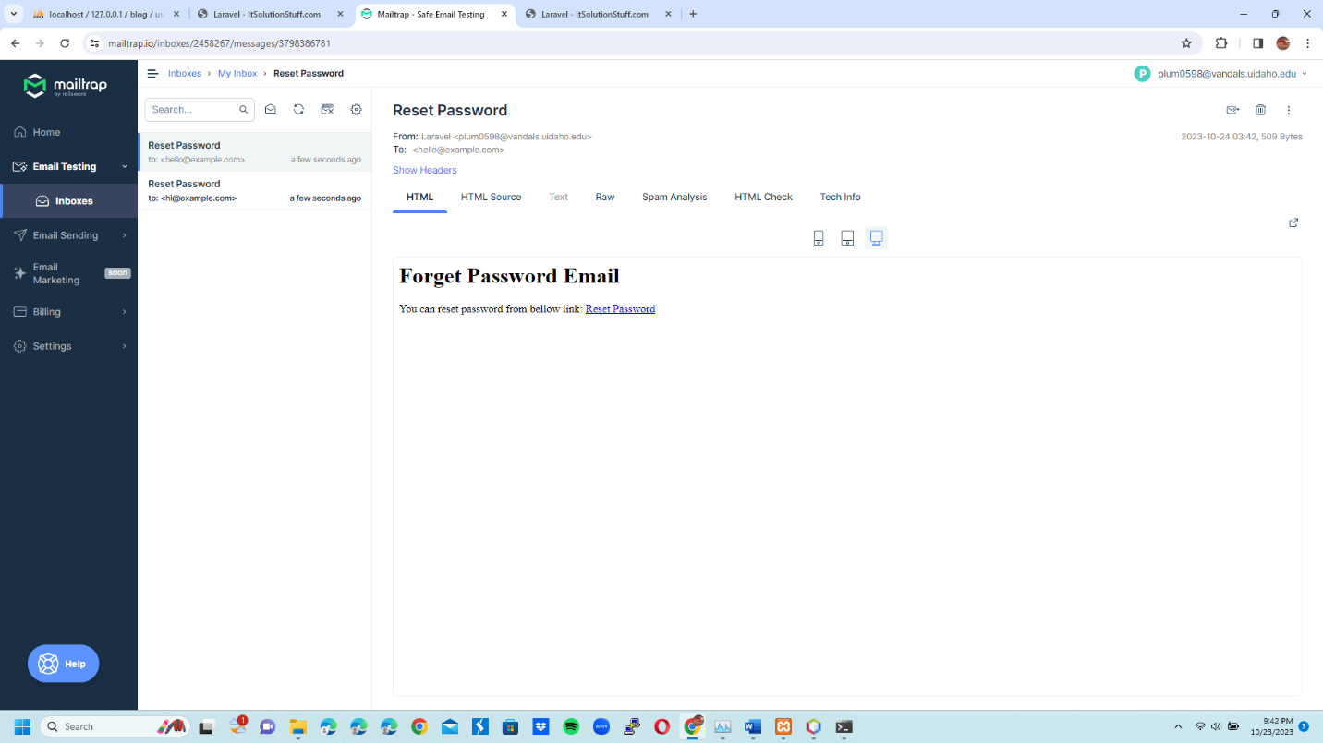

20 Fill hello user info in reset password link:

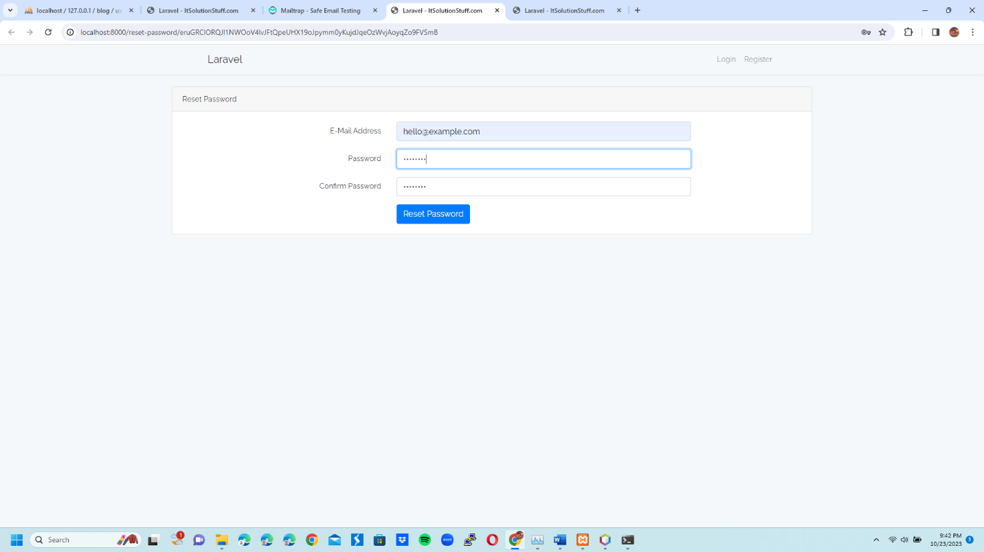

21 Log in with hello’s new password which is 8 characters long compared to 6 previously:

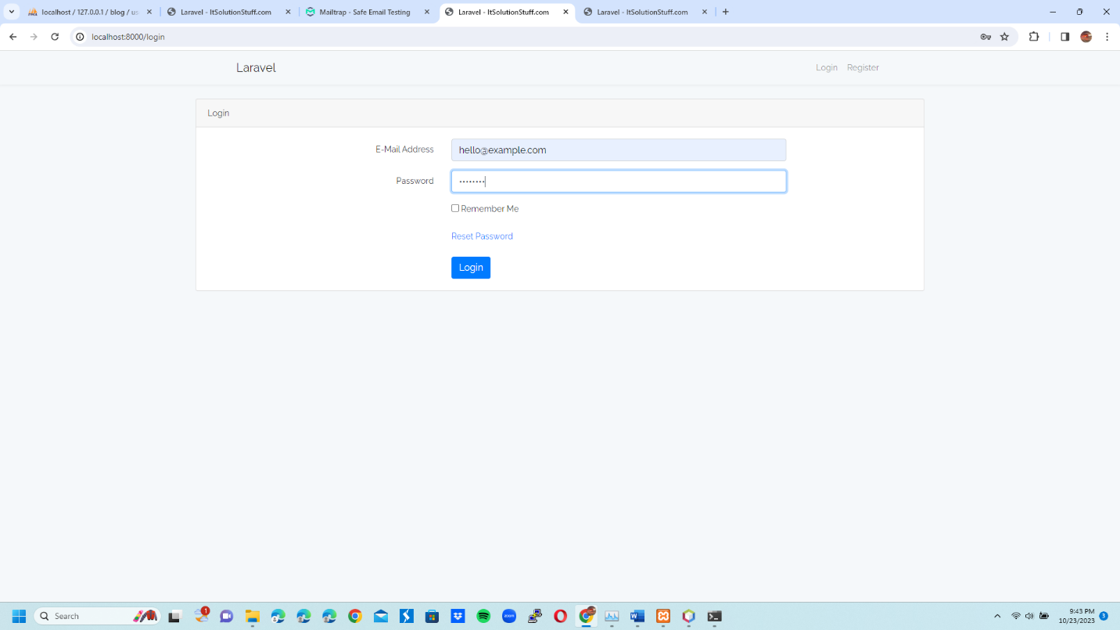

22 Successfully log in to user hello with new password:

